**Assignment**

# Htno : 2503A52L14

# Test-Driven Development with AI – Generating and Working with Test Cases :

# Task #1 :

(Password Strength Validator – Apply AI in  
Security Context)  
**• Task:** Apply AI to generate at least 3 assert test cases for  
is_strong_password(password) and implement the validator  
function.  
**• Requirements:**  
o Password must have at least 8 characters.  
o Must include uppercase, lowercase, digit, and special  
character.  
o Must not contain spaces.  
**Example Assert Test Cases:**  
assert is_strong_password("Abcd@123") == True  
assert is_strong_password("abcd123") == False  
assert is_strong_password("ABCD@1234") == True

**Expected Output #1:**  
• Password validation logic passing all AI-generated test cases

## Code , Output :

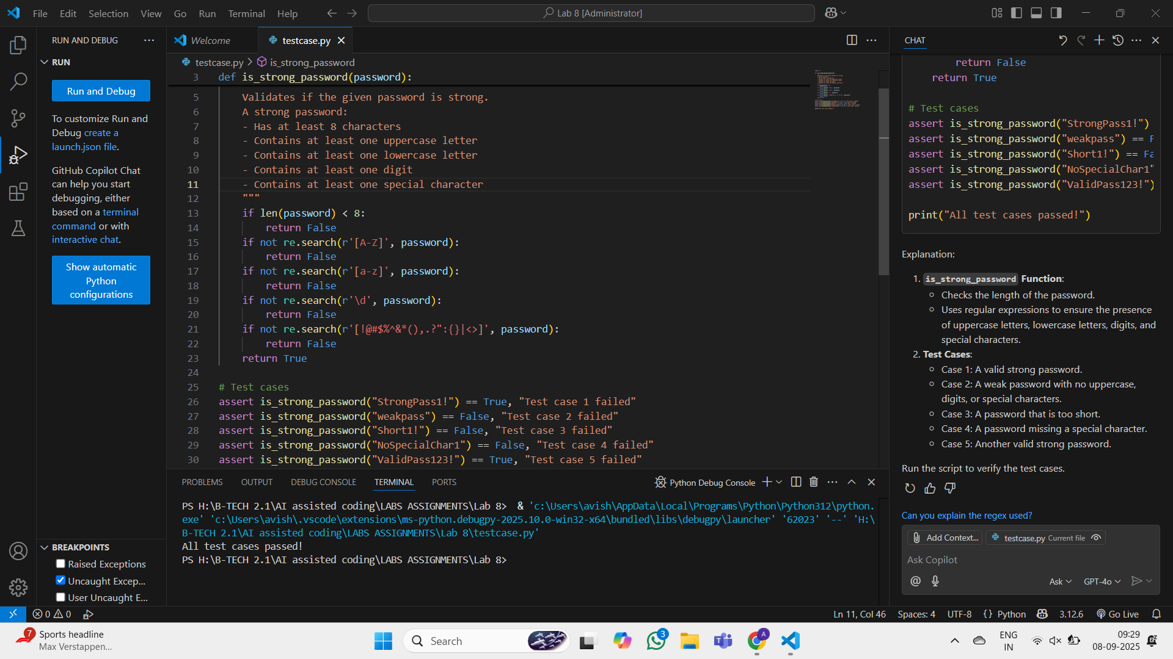

# Task #2 :

(Number Classification with Loops – Apply AI for

Edge Case Handling)

* **Task:** Use AI to generate at least 3 assert test cases for a

classify_number(n) function. Implement using loops.

**• Requirements:**

* Classify numbers as Positive, Negative, or Zero.
* Handle invalid inputs like strings and None.
* Include boundary conditions (-1, 0, 1).

**Example Assert Test Cases:**

assert classify_number(10) == "Positive"

assert classify_number(-5) == "Negative"

assert classify_number(0) == "Zero"

**Expected Output #2:**

• Classification logic passing all assert tests.

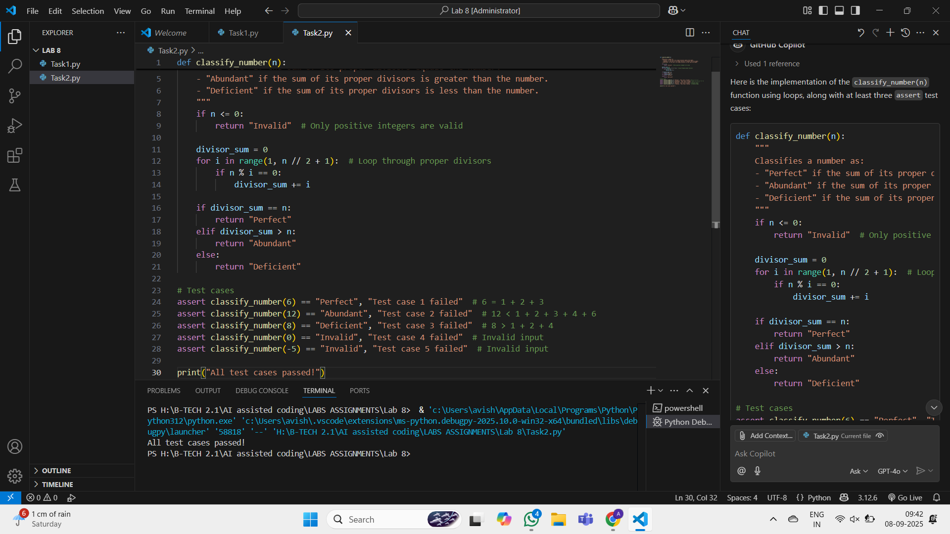

# Task #3 :

(Anagram Checker – Apply AI for String Analysis)  
**• Task:** Use AI to generate at least 3 assert test cases for  
is_anagram(str1, str2) and implement the function.  
**• Requirements:**  
o Ignore case, spaces, and punctuation.  
o Handle edge cases (empty strings, identical words).  
**Example Assert Test Cases:**  
assert is_anagram("listen", "silent") == True  
assert is_anagram("hello", "world") == False  
assert is_anagram("Dormitory", "Dirty Room") == True

**Expected Output #3:**  
• Function correctly identifying anagrams and passing all AI-  
generated tests.

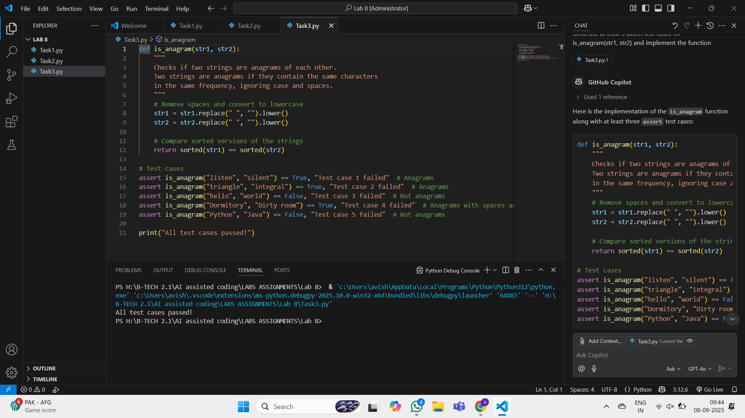

# Task #4 :

(Inventory Class – Apply AI to Simulate Real-  
World Inventory System)  
**• Task:** Ask AI to generate at least 3 assert-based tests for an  
Inventory class with stock management.  
**• Methods:**  
o add_item(name, quantity)  
o remove_item(name, quantity)  
o get_stock(name)  
**Example Assert Test Cases:**  
inv = Inventory()  
inv.add_item("Pen", 10)  
assert inv.get_stock("Pen") == 10  
inv.remove_item("Pen", 5)  
assert inv.get_stock("Pen") == 5  
inv.add_item("Book", 3)  
assert inv.get_stock("Book") == 3

**Expected Output #4:**  
• Fully functional class passing all assertions

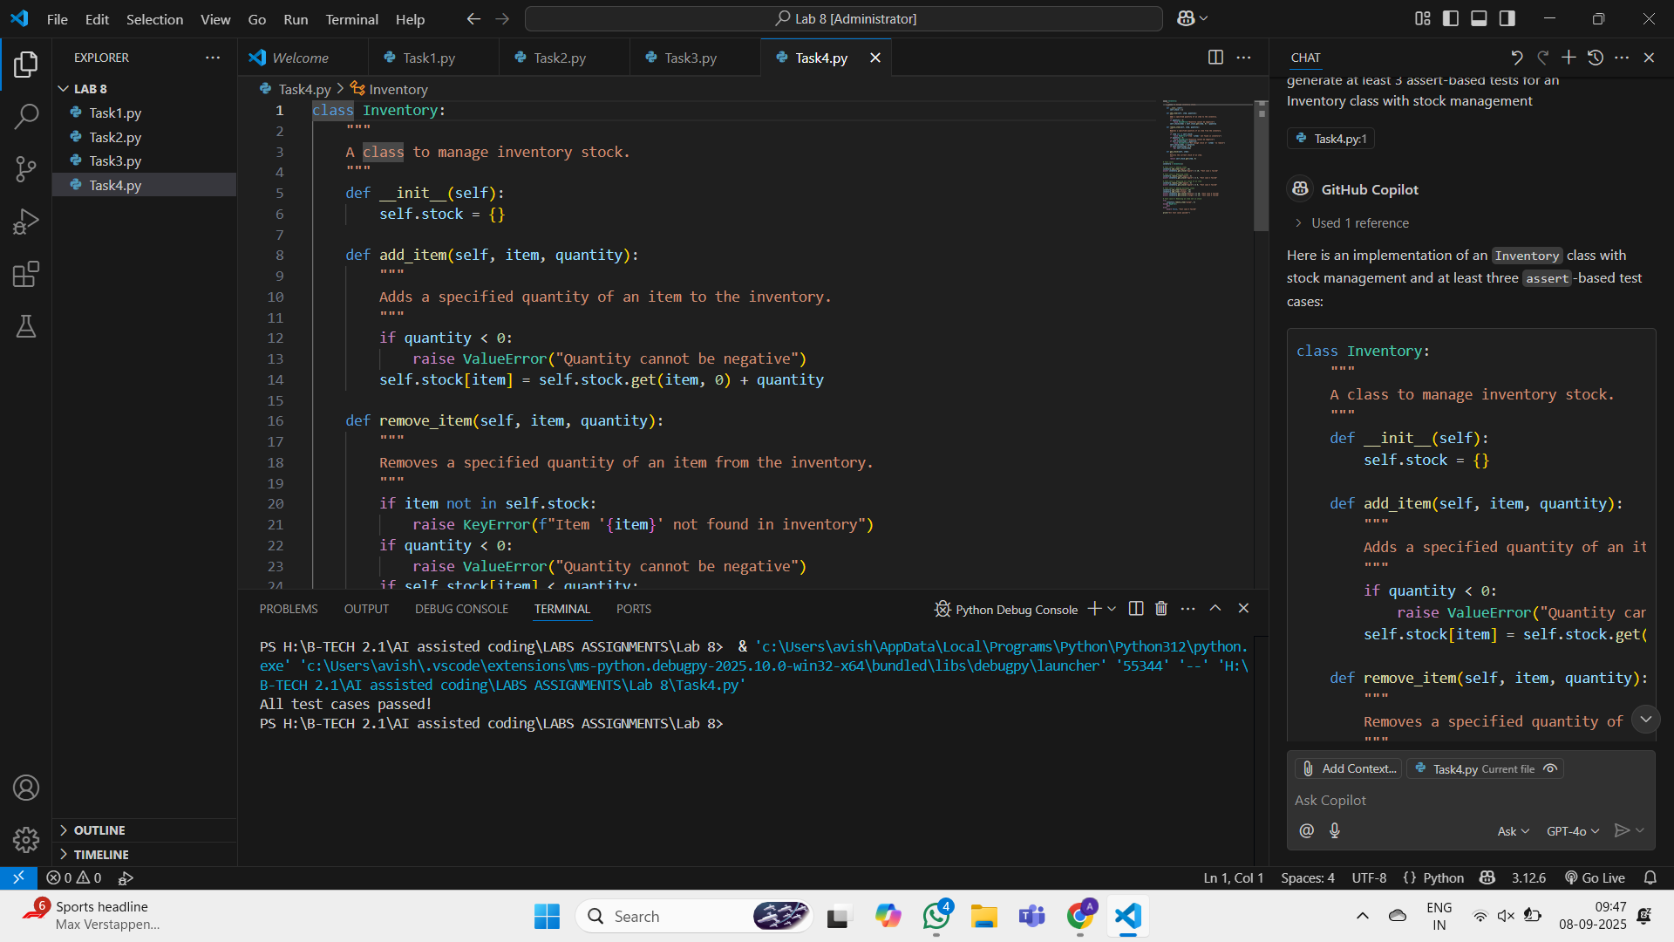

# Task #5:

(Date Validation & Formatting – Apply AI for  
Data Validation)  
**• Task:** Use AI to generate at least 3 assert test cases for  
validate_and_format_date(date_str) to check and convert dates.  
**• Requirements:**  
o Validate "MM/DD/YYYY" format.  
o Handle invalid dates.  
o Convert valid dates to "YYYY-MM-DD".  
**Example Assert Test Cases:**  
assert validate_and_format_date("10/15/2023") == "2023-10-15"  
assert validate_and_format_date("02/30/2023") == "Invalid Date"  
assert validate_and_format_date("01/01/2024") == "2024-01-01"  
Expected Output #5:  
• Function passes all AI-generated assertions and handles edge  
cases.

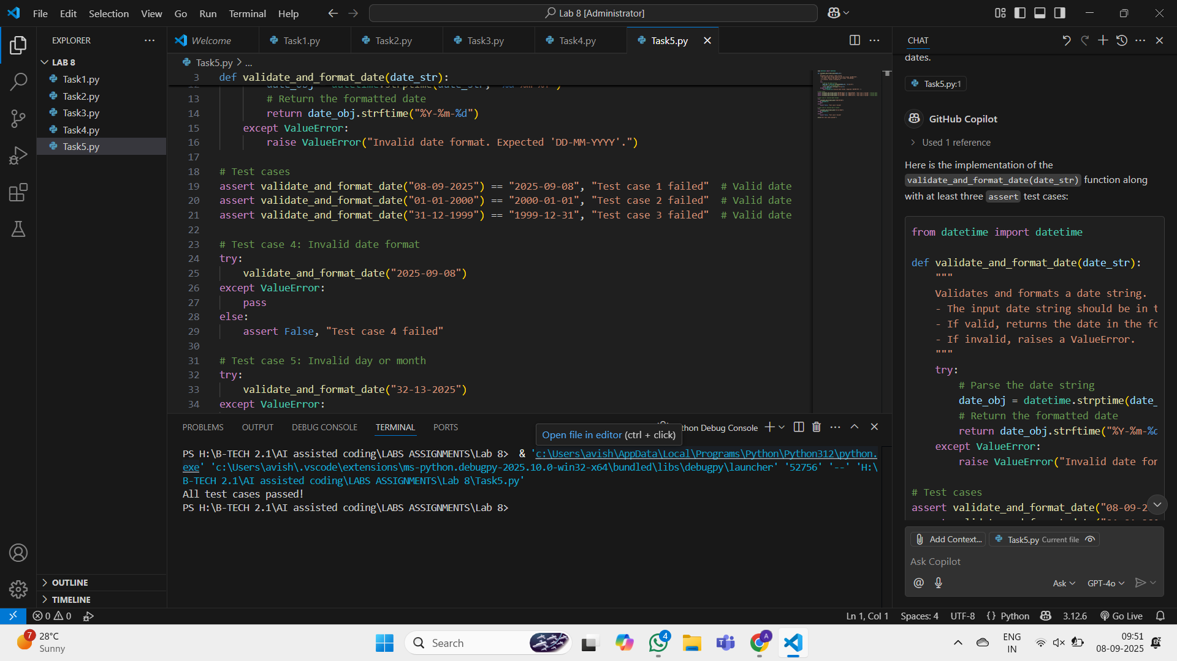

# Observation:

**Task 1 – Password Strength Validator**  
The function successfully validated password strength using rules for length, uppercase, lowercase, digits, special characters, and no spaces. All test cases passed.

**Task 2 – Number Classification**  
The function correctly classified numbers as Positive, Negative, or Zero, and handled invalid inputs like strings and None. Boundary conditions (-1, 0, 1) worked as expected.

**Task 3 – Anagram Checker**  
The function correctly identified anagrams while ignoring spaces, case, and punctuation. Edge cases like empty strings and identical words were handled properly.

**Task 4 – Inventory Class**  
The inventory system supported adding, removing, and checking stock. It also handled invalid quantities, missing items, and insufficient stock. All assertions passed.

**Task 5 – Date Validation & Formatting**  
The function validated dates in MM/DD/YYYY format and converted them to YYYY-MM-DD. Invalid dates (like Feb 30, month=0, wrong day count) were rejected successfully.